Organization profile
2016-17

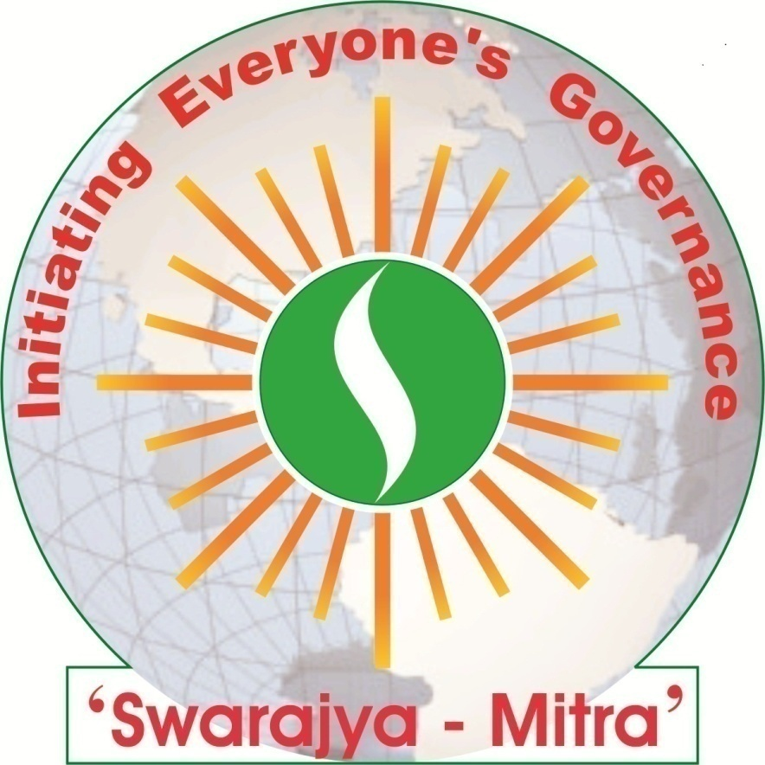

‘Swarajya-Mitra Samajik Sanstha’
(Initiating Everyone’s Governance …)
Registered Society and Public Trust
Facebook: http://www.facebook.com/swarajyamitra.org

Registered Office:
At Post Anjangaon-Bari,
Via Badnera; Tq. Dist. Amravati;
(Maharashtra State), India. Pin – 444701
Telephone No.: 0721-2385204, 09423102983
Email: swarajya.mitra@rediffmail.com
Legal Status of the Organisation and Statutory Fulfilments
Sr. No. | Relevant Act/Scheme | Authority | Registration Number | Registration Date
1. | Society Registration Act, 1860 | Asst. Registrar of Societies, Amravati Division, Amravati | MAH/20/08 (Amravati) | 11/01/2008
2. | Bombay Public Trust Act, 1950 | Asst. Charity Commissioner, Amravati Division, Amravati | F-15445 (Amravati) | 21/02/2008
3. | Permanent Account Number; Income Tax Act, 1961 | Commissioner of Income Tax (Vidarbha), Amravati | AAHTS4925M | 09/05/2008
4. | Income Tax Act, 1961; 12A | Commissioner of Income Tax – III, Amravati | F.No.CIT-III/12AA/2008-09 | 23/01/2009
5. | Tax Deduction Account Number; Income Tax Act, 1961 | Income Tax Officer, Amravati | NGPS11673E | 17/07/2012
6. | The Maharashtra State Tax on Professions, Trades, Callings and Employments Act, 1975 | Professional Tax Officer, Amravati | 27335248970P | 18/07/2012
7. | NGO-Partnership System, Unique ID | NGO-Darpan, Govt. of India, New Delhi | MH/2013/ 0063593 | 00/00/2013

General Body of the Organization - Members of the organization
(As on 31st March 2016)
Sr. No. | Name | Position | Age | Gender | Place | Occupation / Area of Competency
1. | Ms. Shruti Vikram Mehta | President | 40 | Female | Amravati | Entrepreneurship, Legal Aid and Women Empowerment
2. | Dr. Prashant Viththalrao Ingole | Vice-President | 49 | Male | Amravati | Principal, College of Engineering; Educationalist, Technocrat
3. | Dr. Rahul Narendra Bais | Secretary | 44 | Male | Anjangaon Bari | Ayurvedic Medicines, NGO Support Service Provider; Village Self-Governance, Community Based Rehabilitation of Persons with Disabilities
4. | Ms. Karuna Vasant Futane | Executive Committee Member | 57 | Female | Rawala | Farmer; Women Empowerment, Agro-Entrepreneurship
5. | Dr. Avinash Vinayakrao Shirke | Executive Committee Member | 49 | Male | Yavatmal | Principal, College of Social Work; Watershed and Agro-Development
6. | Dr. Vilas Viththalrao Lokhande | Executive Committee Member | 55 | Male | Amravati | Homoeopath Doctor, Social Development Support, Empowerment of Persons with Disabilities
7. | Mr. Nitin Lakshmanrao Anasane | Executive Committee Member | 40 | Male | Amravati | Entrepreneurship, Computer Expert and Technocrat, Social Development Support
8. | Mr. Devaji Navalu Tofa | General Body Member | 59 | Male | Mendha (Lekha) | Farmer; Village Self-Governance, Tribal Culture
9. | Ms. Shubhada Shridhar Deshmukh | General Body Member | 57 | Female | Kurkheda | Social Worker, Women Empowerment

Genesis and Evolution of the Organisation
The brief profile of members of the organisation reflects their vast experience in social development sector. They have exercised brainstorming sessions frequently on current ill-will in society and to explore the roadmap to overcome it. Gist of the analysis did by them is given below -
The ill-will like terrorism, fundamentalism, imperialism, and unlimited profiteering, has almost determined to end the humanity on the strength of ‘muscle-power’. In order to overcome this dangerous situation the world community has bestowed ‘penal-power’ upon the respective governments ever since. But it is a common experience that the violent situations are on increase with the increase in penal-power. The world community seems to have placed on the verge of Total-War situation by adopting the strategy of using more powerful violent methodology in war against the ill-will. During this brutal era, the disproportionate development in socio, economic, and political front caused split in the human community. Dissatisfaction resulted out of inter-community-split is again strengthening the ‘muscle-power’, against which the governments are forced to use the violence based ‘penal-power’. In certain situations the governments take shelter of being a ‘Welfare-State’ and act accordingly. But the beneficiaries of the welfare schemes become more and more dependent, and are forced out of the main stream. This again helps in adding disproportionate development. Unlimited aspiration to win over the Nature on the strength of ‘penal-power’ and ‘muscle-power’, exploitation of our own prosperous habitat through greediness for individual wealth and competition for absolute possession over natural resources, caused inevitable and likely to be irreversible environmental degradation, adverse effects of which human community has to face.
However, efforts are being made all over the world to overcome the ill-situation. According to one’s capacity for identifying the root-cause and to redress thereof, the expected results shall come out in due course. Our analysis shows the root-cause of the current ill-situation in today’s socio-political system. It is our humble and firm belief that total system change can only bring the real prosperity and satisfaction in human kind.
Total system change is directly related to ‘Satta’, which means existence, status, and decision-making power. We are experiencing four types of ‘Satta’ as Autocracy, Oligarchy, Representative Democracy, and Majority Rule Democracy in order to govern and to retain the community. Since everyone in the community is not having decision-making power as a result of which, violence is provoked by these four types of ‘Satta’, which in turn is repressed by more violence. This vicious circle continues. Placing subtle-violence in centre and try to retain on obvious-violence is the inherent fault of the four political-social structures evolved to practise above said ‘Satta’. Avoiding aforesaid inherent fault and stepping in human prosperity is ‘Swarajya’.
‘Swarajya’ means everyone’s own governance. In other words it is ‘governance of and by all (in absolute meaning)’, in which everyone realizes and feels that ‘I am governing’. During pre-independence, London (Ruler) was governing India (Citizens). In the post-independence era, India is governed by elected representatives (Rulers) from Delhi or from Mumbai, i.e. from National or Sate or Panchayat Capital. This is what popularly known as ‘Rajya’. However, every citizen’s integrated and self-governing function with full sense of responsibility is ‘Swarajya’. It is the people’s power and inner-strength based on compassion, love and mutual cooperation. In ‘Swarajya’, every struggle have a dimension of mutual cooperation, compassion and love; as a result of which enmity about nature and ambition or intention to win over ceases. Self-governance and sense of responsibility in ‘Swarajya’ inspires human community to enrich the habitat. When the principle of ‘Consensus’ is placed in Decision-Making, community move forward to establish everyone’s governance.
Inspired for total change in socio-political systems, we have formed voluntary organisation named ‘Swarajya-Mitra Samajik Sanstha’, in 2008; and have resolute following vision-mission.
Vision
Establishing Swarajya that is
Self-governed human community having inner-strength and a sense of responsibility in which, every individual have power and a realization of governance
Life-Time Work
Evolving people’s power based on compassion, love and mutual cooperation
Mission
Promoting community councils making decisions on consensus only to ascertain reverence for life in the village or hamlet
Development Initiatives Planned
and Area of Operation
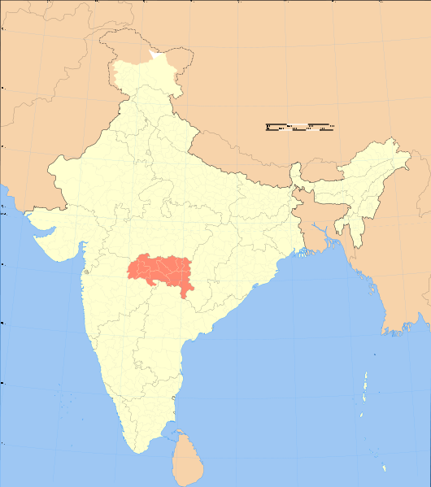

Intensive Work Area in Amravati District
Indirect Outreach Area – Vidarbha Region

Memorandum of Association

(Translated from original Marathi script submitted and approved
by Assistance Charity Commissioner’s Office, Amravati)

Aims and Objectives of the Organisation:
‘Swarajaya-Mitra Samajik Sanstha’ maintains its non-political party, secular, not-for-profit, and voluntary-social character and practices scientific outlook to achieve its following objectives;
- To help in its all possible extent to victims of natural calamities, riots, war, etc.
- Being care giver for persons in scarcity of resources or impoverished or from low-income and social strata; marginalised and unprivileged; especially tribal and depressed (scheduled tribes and castes), women, children and orphans; persons with disabilities; matrimonially separated (deserted) women and widows; helpless aged persons; etc.; and to build capacity within them; to encourage their contribution in development of society; to organise rehabilitation for them; and to achieve their integrated development.
- To arrange formal and informal secular education for children and adults.
- To provide health services to physical and mentally ill persons through clinics, hospitals, nursing homes, and likewise; and to establish and develop sustainable health service system through health education, communication, etc.
- To make aware and build capacity in society for protection, preservation, maintenance and management of food, atmosphere, water and energy.
- To attain overall development of society through public-education and service.
- To set-up formal or informal and need based study-research-training-information centre and audio-visual library for capacity building of target-beneficiary social sectors mentioned in objectives.
- To disseminate organisation’s activities and knowledgeable information through periodicals/non-periodicals, magazines, wall-paper, etc. in public interest.
- To take support of relevant government and non-government schemes, projects and programmes; and to support in it for accomplishment of aforesaid objectives.

List of the Completed and Ongoing Projects/Programmes

Project/Programme | Donor Agency | Amount in INR | Year of Implementation
Community Based Rehabilitation of Persons with Disabilities and Medical Relief Camp | ‘Amhi Amchya Arogyasathi’, Kurkheda | 10,000.00 | 2007-08
Community Based Rehabilitation of Persons with Disabilities and Medical Relief Camp | ‘Amhi Amchya Arogyasathi’, Kurkheda | 10,000.00 | 2008-09
Campaign on Sustainable and Secured Livelihood | ‘Amhi Amchya Arogyasathi’, Kurkheda | 15,000.00 | 2008-09
Community Based Rehabilitation of Persons with Disabilities | ‘Amhi Amchya Arogyasathi’, Kurkheda | 50,000.00 | 2009-10
Community Based Rehabilitation of Persons with Disabilities | ‘CBM SAROS’, Bangalore; and ‘Consulate General of Germany’, Mumbai; through ‘Amhi Amchya Arogyasathi’, Kurkheda | (Indirect funding for programme implementation in the 40 villages) | 2011-12
Right to Education Initiatives | ‘Apeksha Homoeo Society’, Mozari | 1,36,000.00 | 2012-13
Strengthening the Implementation of Right to Education in Maharashtra by Enabling Greater Convergence among Different Stakeholders Working on Child Rights Issues | ‘HIVOS’, Bangalore; through  ‘Apeksha Homoeo Society’, Mozari | (Indirect funding for programme implementation in the 15 villages) | 2012-13
National Environment Awareness Campaign 2013-14 | ‘Ministry of Environment and Forest’, Government of India; through Resource Agency ‘BAIF Development Research Foundation’, Pune | 8,000.00 | 2013-14
‘New Pension System’ (NPS-lite) ‘Swavalamban’ for unorganised sector workers | ‘PFRDA, Govt. of India’, through Aggregator ‘IL&FS Securities Services Limited’, Mumbai; and Mother NGO ‘Shri Sant Gajanan Maharaj Samaj Sevi Sanstha’, Khamgaon | Not Applicable  (Intensive based programme) | 2013-14
Promoting Low External Input Sustainable Agriculture | ‘AWO International’, Mumbai; through ‘AFARM’, Pune | 2,000.00 | 2014-15
Kisan Mitra – “Risks, Farmers’ Suicides and Agrarian Crisis in Vidarbha: There Is A Way Out” | ‘ActionAid India’, Mumbai; through  ‘Apeksha Homoeo Society’, Mozari | (Indirect funding for programme implementation in the 15 villages) | 2014-15
Kisan Mitra – “Risks, Farmers’ Suicides and Agrarian Crisis in Vidarbha: There Is A Way Out” | ‘ActionAid India’, Mumbai; through  ‘Apeksha Homoeo Society’, Mozari | (Indirect funding for programme implementation in the 15 villages) | 2015-16
Promoting Low External Input Sustainable Agriculture | ‘AWO International’, Mumbai; through ‘AFARM’, Pune | 4,600.00 | 2015-16
Vidarbha Drought Relief Project | ‘Caring Friends’, Mumbai; through ‘Dilasa’, Ghatanji | 2,00,000.00 | 2015-16
‘Maze Gaon Mazi Shala’ (My Village My School) Life Skill Education Program | ‘Tathapi’, Pune | (Training and technical support for implementation in 2 schools) | 2015-16
Strengthening Ekal Mahila Sangathan (Single Women’s Organisation) | ‘CORO for Literacy’, Mumbai | Grassroots Fellowship and Mentoring support for 2 members of Single Women’s Organisation | 2016
Movement for Creating School-Drop-Out Free Zones in Vidarbha | Community Contribution and ‘IIFCL’, New Delhi; through ‘Apeksha Homoeo Society’, Mozari | 1,77,100.00 | 2016
Inclusive Socio-Economic Development of Persons with Disabilities and Marginalized Women & Families in 90 villages of Amravati District in Maharashtra State, India | Own Fund and Resource Support from ‘Naman Seva Samiti’, Betul | 6,00,000.00 | 2016-17
Sewing Machine Support to Ekal Mahila and Sewing Skill Development School | NAAM Foundation, Pune; and Mr. Anant Rajurkar | (19 Sewing Machines) | 2016-17

Core Staff Members of the Organisation
(As on 31st March 2016)

Name | Gender | Education | Designation | Remuneration
Arati Bais | Female | M.S.W. | Project Coordinator | Paid
Chandrashekhar Kusumbiraj | Male | M.A., B.Ed. | Field Worker | Paid
Rajju Kamatkar | Female | H.S.S.C. | Grassroots Fellow | Paid
Sangita Borkar | Female | B.A. | Grassroots Fellow | Paid
Varsha Sahare | Female | B.A. | Grassroots Fellow | Paid

Area of Competency and Innovative Approaches
in Development Initiatives
1. Gender Equity and Power to Deprived People
- ‘Swarajya-Mitra’ is a pioneer organization in exploring ‘Disability Deprivation /Development Index’.
- Community based rehabilitation of persons with disabilities and women in need.
- Strengthening community organizations - Ekal Mahila Sangthan (Single Women’s Organization), Apang Jan Sangthan (Disabled People’s Organization), Majur-Kisan Sangthan (Laborers-Farmers Organization), Joint Liability Groups, etc.
2. Sustainable-Secured Livelihood and Prosperity
- ‘Swarajya-Mitra’ has revealed new avenue for addressing Agrarian Crisis by means of ‘Agriculture Income Formula’.
- Community based planning and monitoring of public services for agriculture development, viz. Electricity Distribution, Prime Minister’s Package for Suicide Affected Households, etc.
- ‘Livelihood Assessment and Priority Matrix Ranking’ for appropriate enterprises for Women with Disabilities and Women headed households and hand holding support to them.
- Planning, monitoring and implementation for village livelihood assets building through Maharashtra – Mahatma Gandhi National Rural Employment Guarantee Scheme.
3. Life-Oriented Education for Everyone including Kids to Aged
- ‘Swarajya-Mitra’ is working on designing inclusive education system for ‘Walked Out’ and ‘Forced Out’ children.
- Community based planning and monitoring for righteous implementation of Right to Education Act, 2009.
- Imparting Life Skill Education to adolescent students through ‘Maze Gaon Mazi Shala’ (My Village My School) campaign.
4. Treatment and Preventive Health Education and Services on Individual, Environment and Social/Life style Level
- Community based planning and monitoring of public health services
5. Promoting Consensus Decision-Making Community Councils
- Six-component community setup

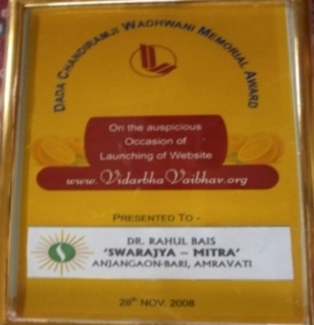
AWARDS

Dada Chandiramji Wadhwani Memorial Award 2008
for social initiatives
by ‘Vidarbha Vaibhav’, Nagpur

